Name ______________________________ Homework March 27-31
Put your initials by each night that your child practiced the following:
____Monday ____Tuesday ____Thursday
*Nightly Homework*
1. Read the Start Right Reader page.
2. Count numbers 1-100.
3. Practice assigned Sight Word list in red reading folder.

Monday: Write the correct initial digraph next to the word.
_______ 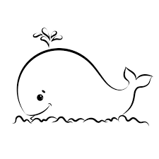_______

_______ _______

Circle the correct beginning sound for each word.
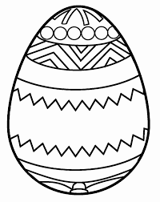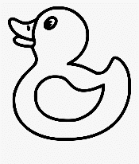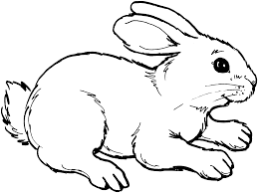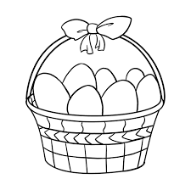
f e t d c n r n g n d b

Tuesday- Practice writing each spelling word three times.
rip nod pup zip
________ _________ ________ ________
________ _________ ________ ________
________ _________ ________ _______

wax net dug sad
________ _________ _________ ________
________ _________ _________ ________
________ _________ _________ ________

Thursday- Color the picture of an Easter egg and write three sentences about the egg. Include upper case letter at the beginning, finger spaces between words, and correct punctuation.
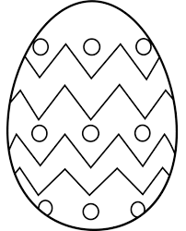

Start Right Reader Week of March 27-31
Directions: Let your child read this to you.

Words to Know
could now then this

Big Mess
“Chuck, look at that den! We must get logs to fix it,” yells Peg. “I could chop this, Peg,” said Chuck. Peg nods. “Yes, Chuck. Chop it!” Chuck chops. Big chips whiz past Peg. “Stop! Stop! Stop that now!” quacks Deb Duck. “It will tip!” “We did not we you, Deb,” said Peg. “We will fix this big mess.” Chuck and Peg pick up the chips. Then they stack them. “Good job!” quacks Deb.
Comprehension Questions: (Parents, ask your child the questions about the story.)

Who are the main characters in the story? What does Chuck do to the tree?
What happens when Chuck chops? Who tells Chuck to stop?
Why does Deb Duck tell Chuck to stop? How do Chuck and Peg fix the mess?

Blend and Read: Read these words. Find these words in the story.
them this

whiz
they said get stop

Initial each night.
Mon. | Tues. | Thurs.

